1.Create a Bucket in IBM object storage.

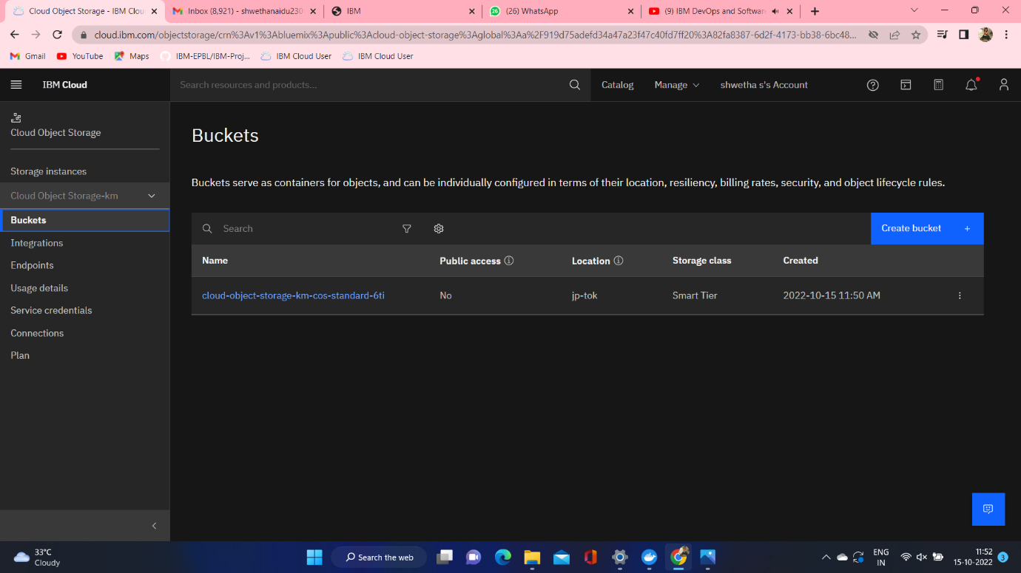

2.Upload 5 images  to ibm object storage and make it public. write html code to displaying all the 5 images.

<!DOCTYPE html>

<html>

<head>

<link rel="stylesheet"href="https://cloud-object-storage-km-cos-standard-6ti.s3.jp-tok.cloud-object-storage-appdomain.cloud/new.css">

</head>

<body>

<h1>This images are from cloud object storage</h1>

<div class="grid-container">

<div class="item1"><img src="cloud-object-storage-km-cos-standard-6ti.s3.jp-tok.cloud-object-storage-appdomain.cloud/ibm1.jpg" alt="ibm1.jpg"></div>

<div class="item1"><img src="cloud-object-storage-km-cos-standard-6ti.s3.jp-tok.cloud-object-storage-appdomain.cloud/ibm2.webp" alt="ibm2.webp"></div>

<div class="item1"><img src="cloud-object-storage-km-cos-standard-6ti.s3.jp-tok.cloud-object-storage-appdomain.cloud/ibm3.jpg" alt="ibm3.jpg"></div>

<div class="item1"><img src="cloud-object-storage-km-cos-standard-6ti.s3.jp-tok.cloud-object-storage-appdomain.cloud/ibm4.png" alt="ibm4.png"></div>

<div class="item1"><img src="cloud-object-storage-km-cos-standard-6ti.s3.jp-tok.cloud-object-storage-appdomain.cloud/ibm5.png" alt="ibm5.png"></div>

</div>

</body>

</html>

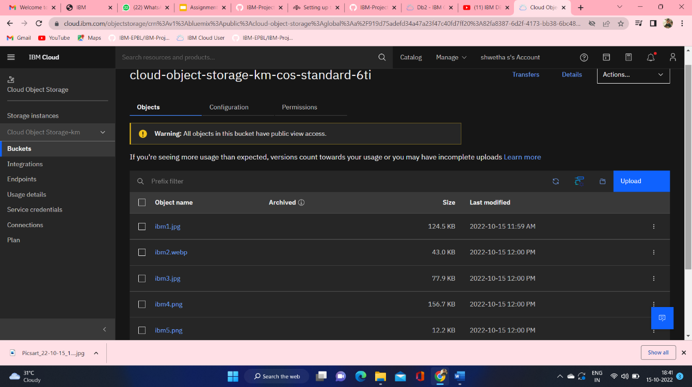

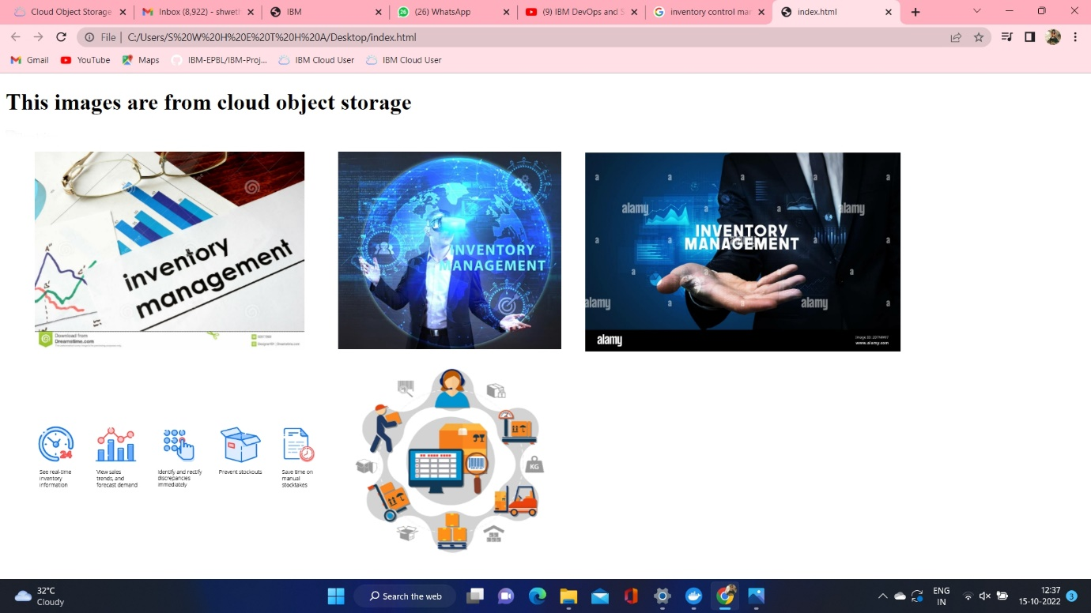

3.Upload a css file to the object storage and use the same css using external link in your HTML page.

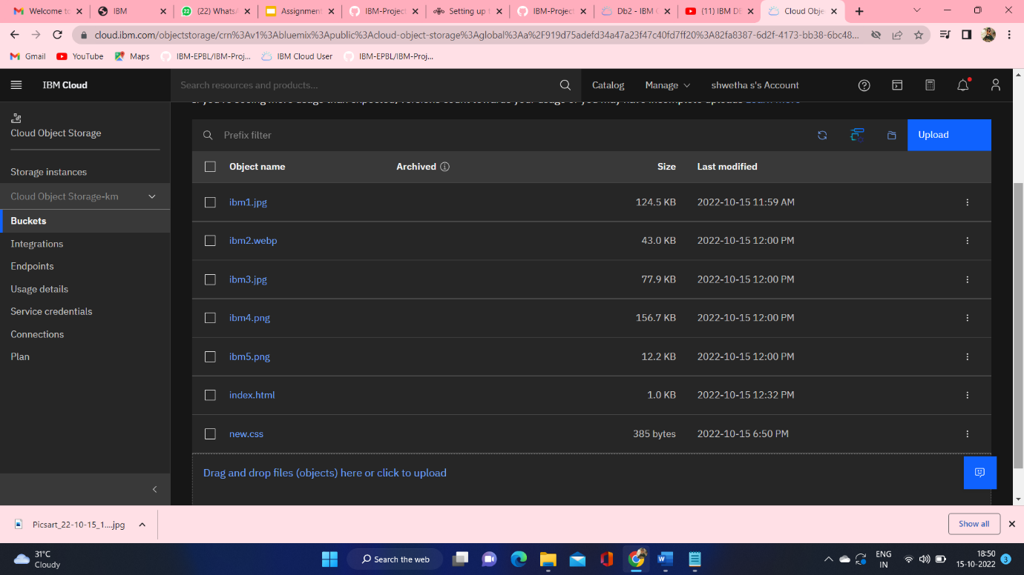

Css file used in html

